August 19, 2015

The Honorable Ron Wyden
United States Senate
221 Dirksen Senate Office Building
Washington, DC 20510

Dear Senator Wyden:

The Oregon State Chamber of Commerce is writing today to discuss a recent proposal from the United States Department of Labor (DOL) that would have a detrimental impact on retirement savings for Oregonians and Americans throughout the country.

Our organizational mission is to support and represent Oregon’s local business community by serving as its advocate on business issues and by strengthening local chambers. We are deeply focused on public policy, economic development, and tourism issues. Given the important role that small businesses play in our state, we feel it is important to oppose these DOL rules that will place restrictions on the financial advice available to small businesses wishing to provide their employees with retirement options. We ask that you will work to fix these rules and prevent unintended, negative consequences.

There is widespread concern that these restrictions will directly translate into the diminished availability of retirement investment advice for small businesses and their employees. This is particularly concerning given that the DOL rule is designed to help small savers and keep investors’ best interest in mind. Experts who have studied it suggest the employees of small businesses (aka small savers) could lose access to benefits they can affordably receive today. Essentially, this ruling would have the opposite effect than intended.

A congressional approach to this issue makes sense and will result in a better outcome than is possible with the DOL handling this issue entirely. If we are going to solve the retirement crisis in America, Congress should have a voice in this process to guarantee the best results.

Sincerely,

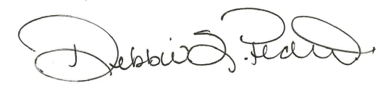

Debbie Pedro, Chair

